Install mysql for Mac:
Last update: Mar 26, 2022
https://dev.mysql.com/doc/refman/8.0/en/macos-installation.html
https://dev.mysql.com/doc/refman/8.0/en/macos-installation-pkg.html

- Go to https://dev.mysql.com/downloads/mysql/
- Select “macOS”, “macOS 11 (x86, 64-bit)”, click “Download”.
- Download mysql-8.0.27-macos11-x86_64.dmg (422.1M) (choose the latest version)

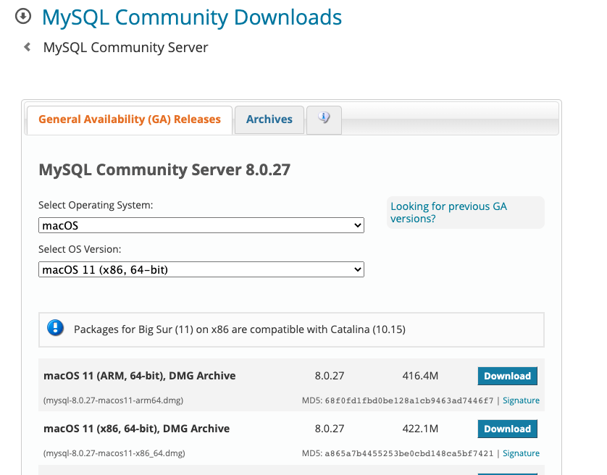

- When ask to login, click “No thanks, just start my download”.
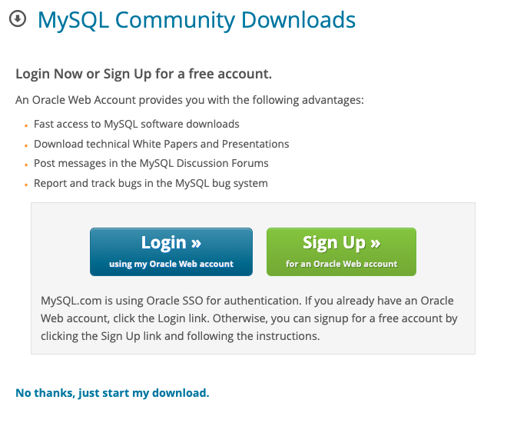
- Double click downloaded file to install. mysql-8.0.27-macos11-x86_64.dmg
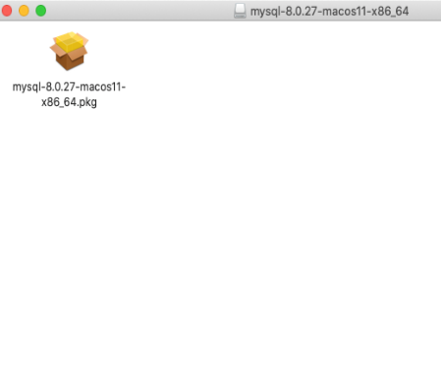
- Click “continue” when ask to check the system.
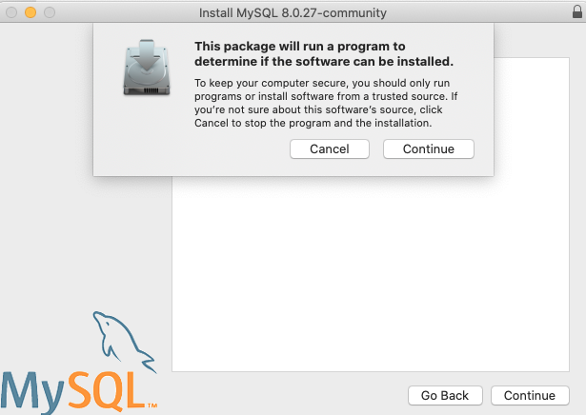
- Click “continue” when ask to install MySQL.
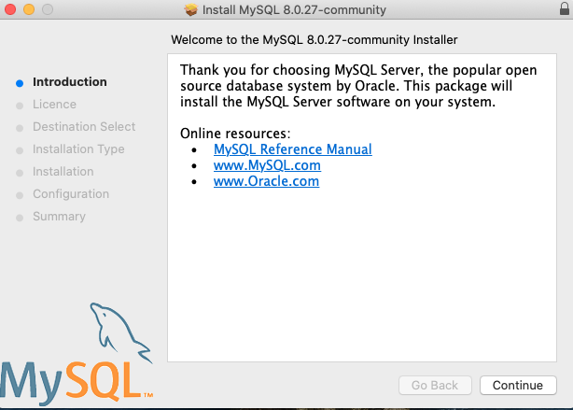
- Click “continue” after reviewing software licence agreement.
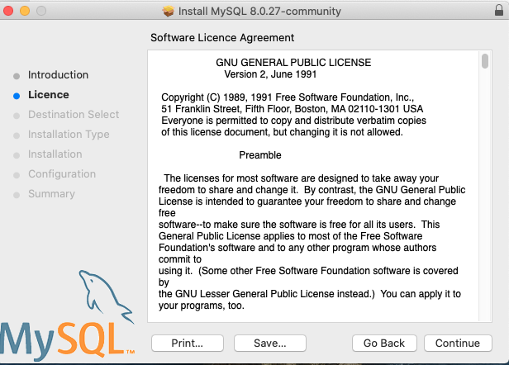
- Click “Agree” to the terms.
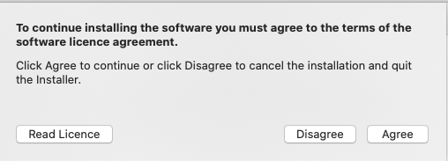
- Click “Install” to start the installation.
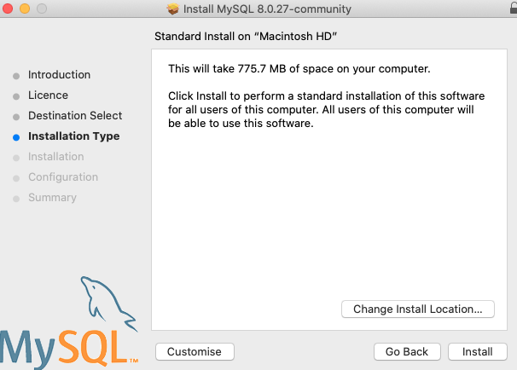
- Choose “Use Strong Password Encryption”, click “Next”.
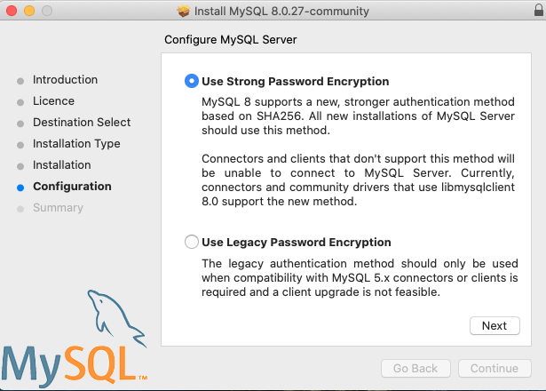
- Enter “Password” for root, un-select “Start MySQL Server once the installation is complete”.
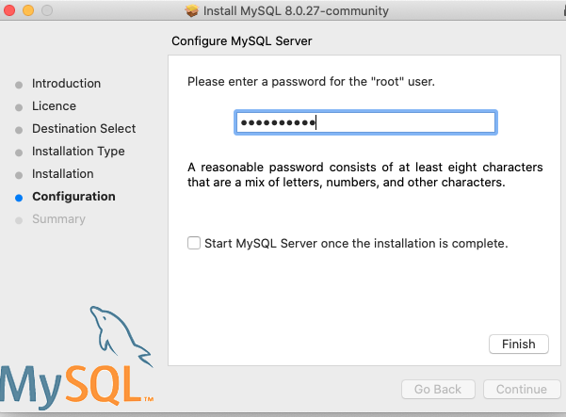
- Click “Close” when complete.
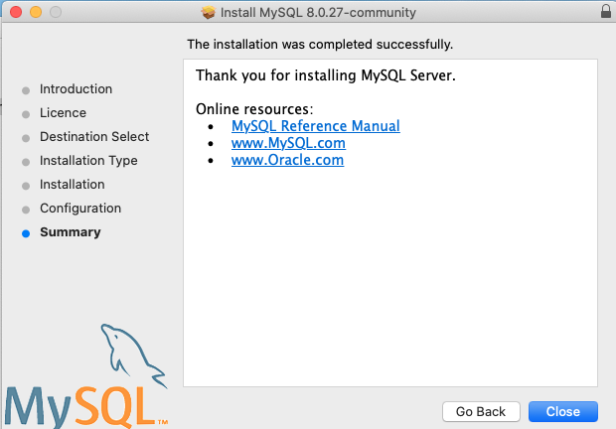

- MySQL was installed in /usr/local/mysql-8.0.27-macos11-x86_64 directory with a symbolic link /usr/local/mysql.

- Create a working directory: ~/mysql_workspace/comp7780 for your lab and final project.

- Add mysql bin to your path. (See below appendix A)
- Start/Stop MySQL Database (See below appendix B)
- Then logon to MySQL Monitor (from terminal, issue the following command):
mysql -u root -p PassWord

Appendix A

How to view the current PATH variable?
From terminal, enter the following:
echo $PATH
NOTE: make sure /usr/local/mysql/bin is in your path.
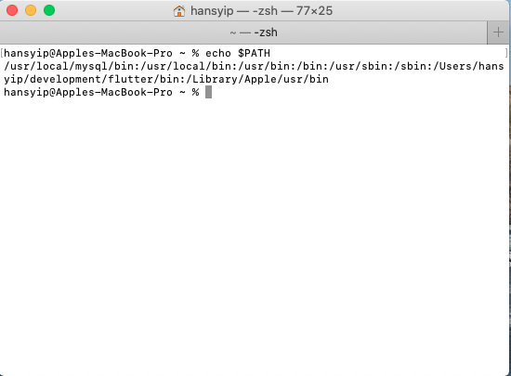

How to set the PATH variable?
https://unix.stackexchange.com/questions/246751/how-to-know-why-and-where-the-path-env-variable-is-set
https://techpp.com/2021/09/08/set-path-variable-in-macos-guide/
Mac OS before Catalina = bash (.bashrc or .bash_profile)
Mac OS after Catalina = zsh (.zshrc or .zsh_profile)
How to find out what shell that you are using?
echo $SHELL
You can either create/modify .zprofile in your home directory with the following:
export PATH=/usr/local/mysql/bin:$PATH
OR

For permanent update to your PATH, you can modify /etc/paths

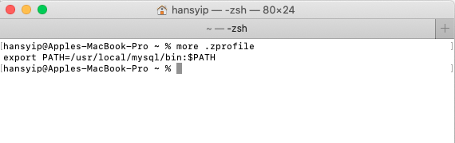
To check if MySQL has been installed, enter:
ls /usr/local/

Appendix B
To Start/Stop MySQL DB:

- System Preferences:
- Click “System Preferences”, click “MySQL” icon from the bottom.
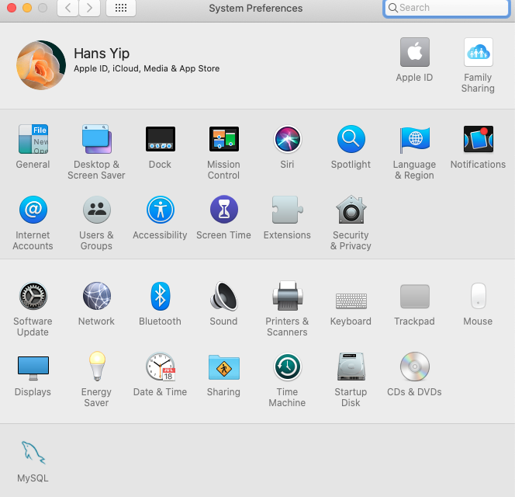
- Click “Start MySQL Server”, enter password if prompt. Then, MySQL instance will be activated.
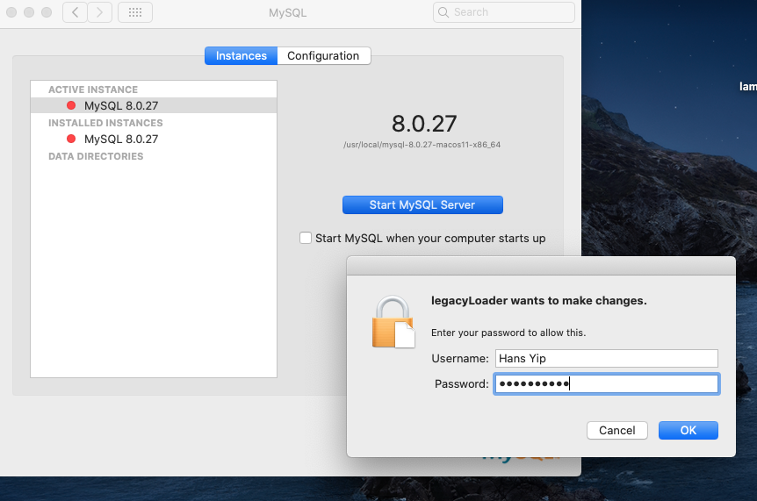
- To stop MySQL DB, click “Stop MySQL Server”.
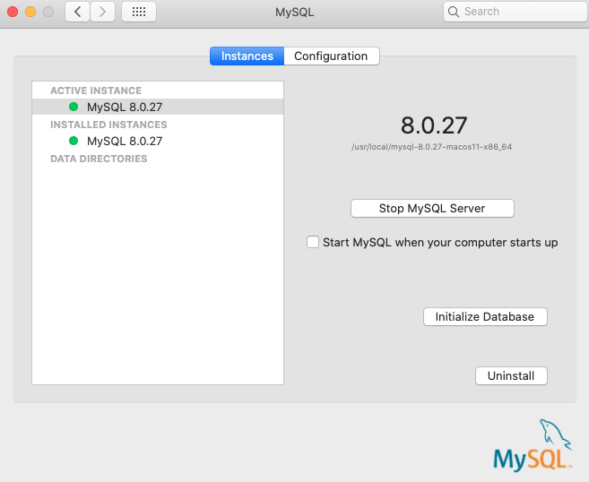
- Command line:

https://osxdaily.com/2014/11/26/start-stop-mysql-commands-mac-os-x/

- To start MySQL DB from terminal:
sudo /usr/local/mysql/support-files/mysql.server start

- To stop MySQL DB from terminal:
sudo /usr/local/mysql/support-files/mysql.server stop

